24/10/26

CO2 -ASSSESMENT TOOL 2 SCENARIO BASED
NAME: NATURAL LANGUAGE PROCESSING COURSECODE: DSA0308
NAME: K.Parameshwar reddy REG.NO: 192324194

Question 1: Morphological Processing for Search Engine Indexing

Aim
To develop a Python program to identify prefixes, suffixes, and root words in disagree, agreement, and agreeable, and normalize them for sentiment analysis.
Python Code :
words = ["analyzing", "analysis", "analytical"]
rules = {
"analyzing": ("analyze", "ing", "Inflectional"),
"analysis": ("analysis", "None", "Base/related form"),
"analytical": ("analysis", "tical", "Derivational")}
for word in words:
root, suffix, category = rules[word]
normalized = "analysis"
print("Word:", word)
print("Root:", root)
print("Suffix:", suffix)
print("Type:", category)
print("Normalized Form:", normalized)
print()

Output

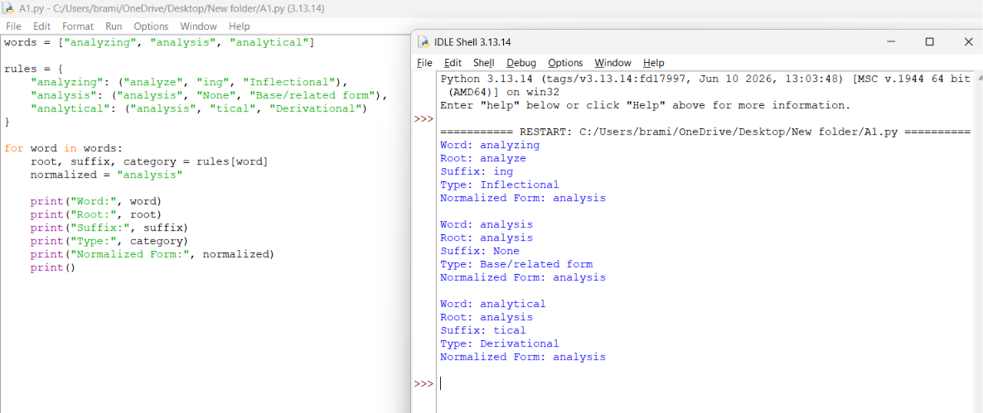

Result
The Python program displays the predefined root, suffix, category, and normalized representation for all three input words. This demonstrates how a rule-based mapping can group related terms for search indexing.

Question 2: Morphology-Based Word Normalization Using Python

Aim
To implement a Python program that analyzes govern, government, and governance and maps them to the shared base govern for text organization and retrieval.
Python Code:
words = ["govern", "government", "governance"]
rules = {
"govern": ("govern", "None", "Verb", 0),
"government": ("govern", "ment", "Noun", 1),
"governance": ("govern", "ance", "Noun", 1)}
print("Morphological Analysis Report")
for word in words:
root, suffix, word_class, level = rules[word]
print("\\nWord:", word)
print("Root:", root)
print("Suffix:", suffix)
print("Word Class:", word_class)
print("Derivational Level:", level)
print("Normalized Form:", root

Output
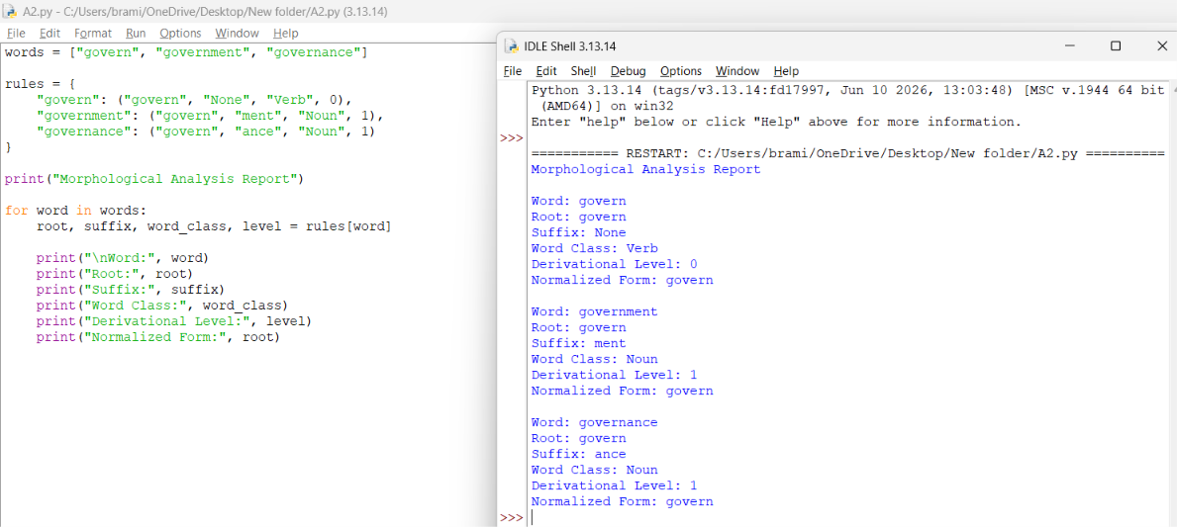

Result
The program identifies the supplied morphological details and maps govern, government, and governance to govern. This shared representation can help group related news articles for categorization and document clustering.

